Problem: 1. Write a C++ program top print 1-100 numbers using loop.

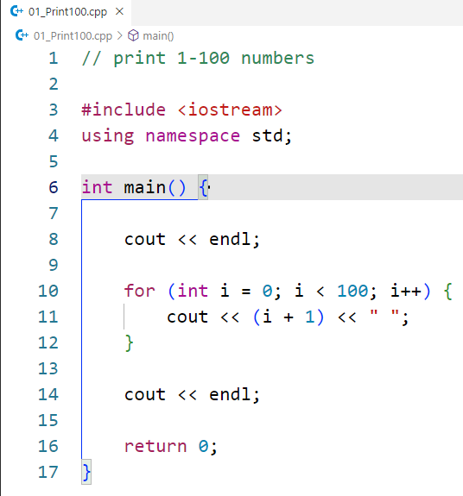Code:

Output:

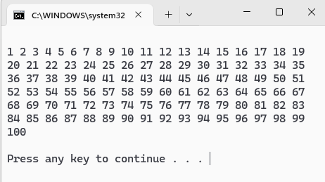

Problem 2: Write a C++ a program to input an array of user-defined size and display its elements.

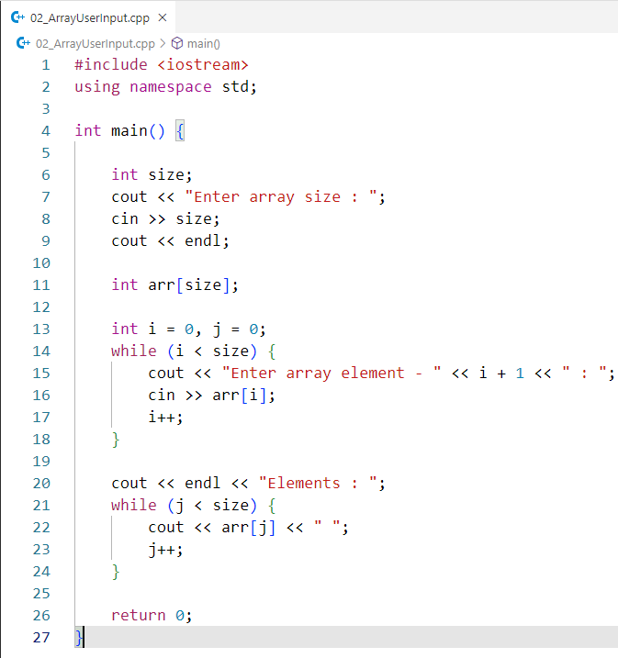Code:

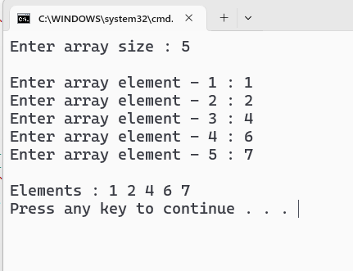Output:

Problem 3: Write a C++ program to input an array of user-defined size, calculate the sum of its elements, and display the result.

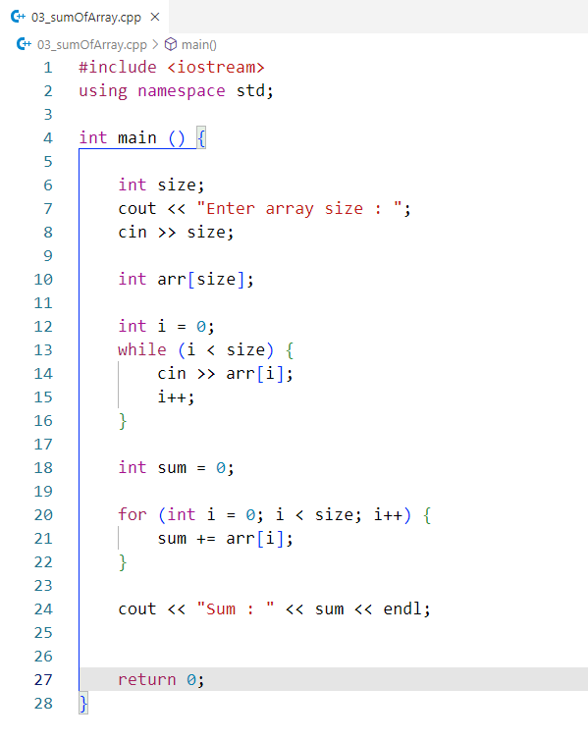Code:

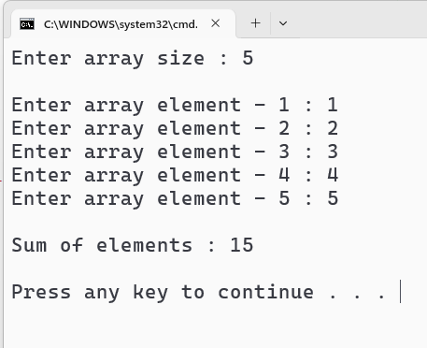Output:

Problem 4: Write a C++ program to input an array of user-defined size, find the maximum and minimum elements, and display them.

Code:

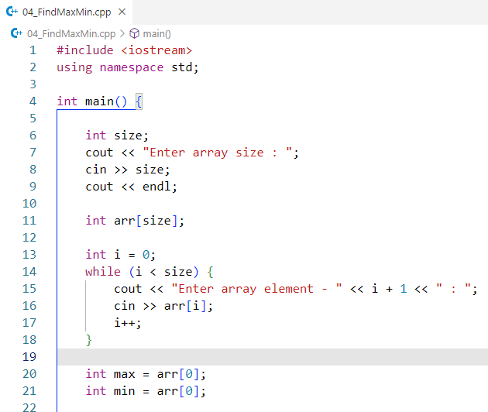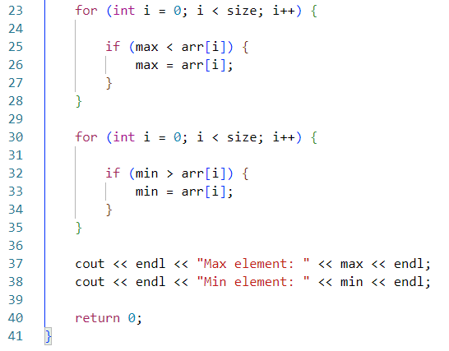

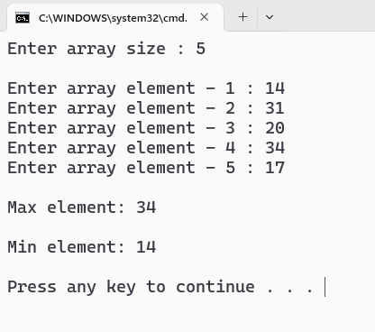Output:

Problem 5: Write a C++ program to input an array of user-defined size, separate the even and odd elements, and display them accordingly.

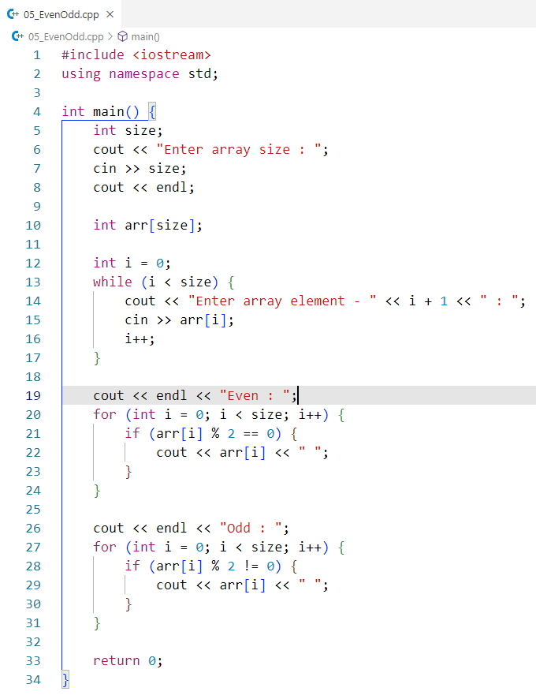Code:

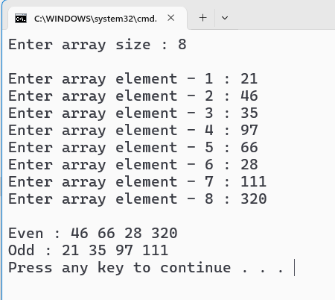Output: